***Experiment 9***

*Basic Fire Alarm System :*

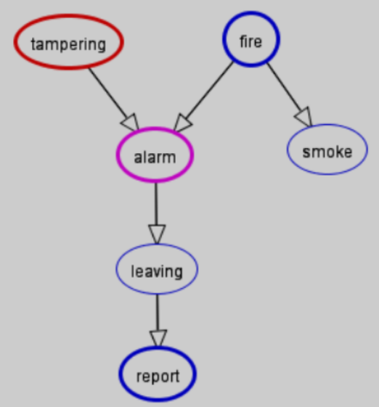

*Probabilities of each node :*

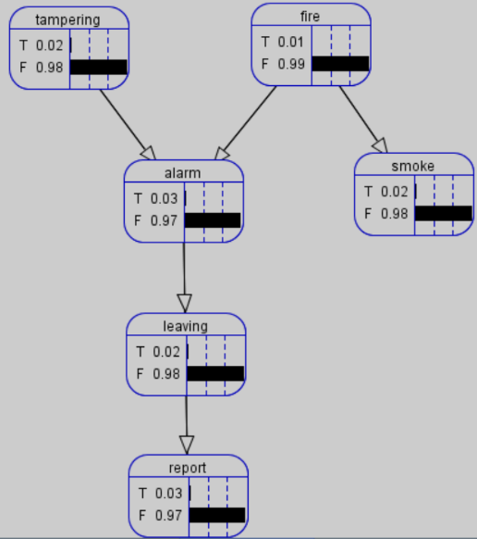

***Belief and Decision Network Queries :***

*Querying the probability of a node :*

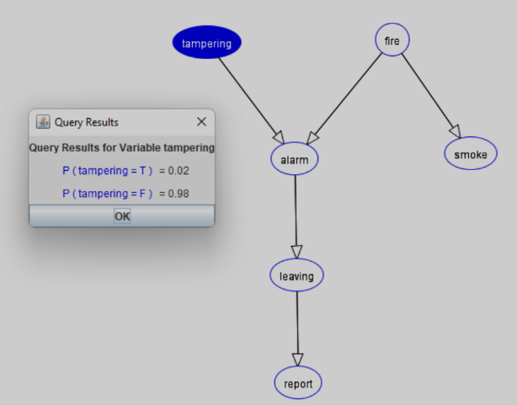

***Changing the probability of a node :***

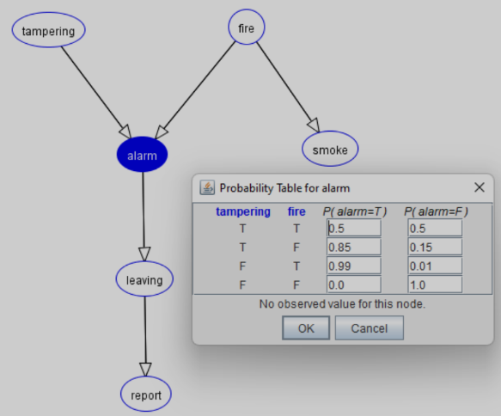

***Asking and Answering Questions :***



